|  |  |
| --- | --- |
| LIFE logo | **HOLY CROSS COLLEGE**  **SEMESTER 1, 2020**  **Question/Answer Booklet** |

Please place your student identification label in this box

11 PHYSICS

Student Name ___________________________________

Student’s Teacher __________________________________________

#### Time allowed for this paper

Reading time before commencing work: 10 minutes

Working time for paper: 3 hours

**Materials required/recommended for this paper**

To be provided by the supervisor

This Question/Answer Booklet

Multiple-choice Answer Sheet

Data Sheet

***To be provided by the candidate***

Standard items: pens, pencils, eraser, correction fluid, ruler, highlighters

Special items: non-programmable calculators satisfying the conditions set by the School Curriculum and Standards Authority for this course

**Important note to candidates**

No other items may be taken into the examination room. It is **your** responsibility to ensure that you do not have any unauthorised notes or other items of a non‑personal nature in the examination room. If you have any unauthorised material with you, hand it to the supervisor **before** reading any further.

**Structure of this paper**

|  |  |  |  |  |  |
| --- | --- | --- | --- | --- | --- |
| Section | Number of questions available | Number of questions to be answered | Suggested working time  (minutes) | Marks available | Percentage of exam |
| Section One:  Short Answers | 11 | 11 | 50 | 50 | 30 |
| Section Two:  Problem-solving | 6 | 6 | 100 | 100 | 60 |
| Section Three:  Comprehension | 1 | 1 | 30 | 16 | 10 |
|  | | | | 166 | 100 |

**Instructions to candidates**

1. The rules for the conduct of examinations at Holy Cross College are detailed in the College Examination Policy*.* Sitting this examination implies that you agree to abide by these rules.

2. Write your answers in this Question/Answer Booklet.

3. Working or reasoning should be clearly shown when calculating or estimating answers.

4. You must be careful to confine your responses to the specific questions asked and to follow any instructions that are specific to a particular question.

5. Spare pages are included at the end of this booklet. They can be used for planning your

responses and/or as additional space if required to continue an answer.

• Planning: If you use the spare pages for planning, indicate this clearly at the top of the

page.

• Continuing an answer: If you need to use the space to continue an answer, indicate in

the original answer space where the answer is continued, i.e. give the page number.

Fill in the number of the question(s) that you are continuing to answer at the top of the

page.

6. Answers to questions involving calculations should be ***evaluated and given in decimal***

***form*.** It is suggested that you quote all answers to ***three significant figures***, with the

exception of questions for which estimates are required. Despite an incorrect final result,

credit may be obtained for method and working, providing these are ***clearly and legibly set***

***out***.

7. Questions containing the instruction *"****estimate****"* may give insufficient numerical data for their

solution. Students should provide appropriate figures to enable an approximate solution to

be obtained. Give final answers to a maximum of ***two significant figures*** and include appropriate units where applicable.

8. Note that when an answer is a vector quantity, it must be given with magnitude and direction.

9. In all calculations, units must be consistent throughout your working.**SECTION ONE: Short Answers**

**Marks Allotted: 50 marks out of 166 total.**

Attempt ALL 11 questions in this section. Answers are to be written in the space below or next to each question.

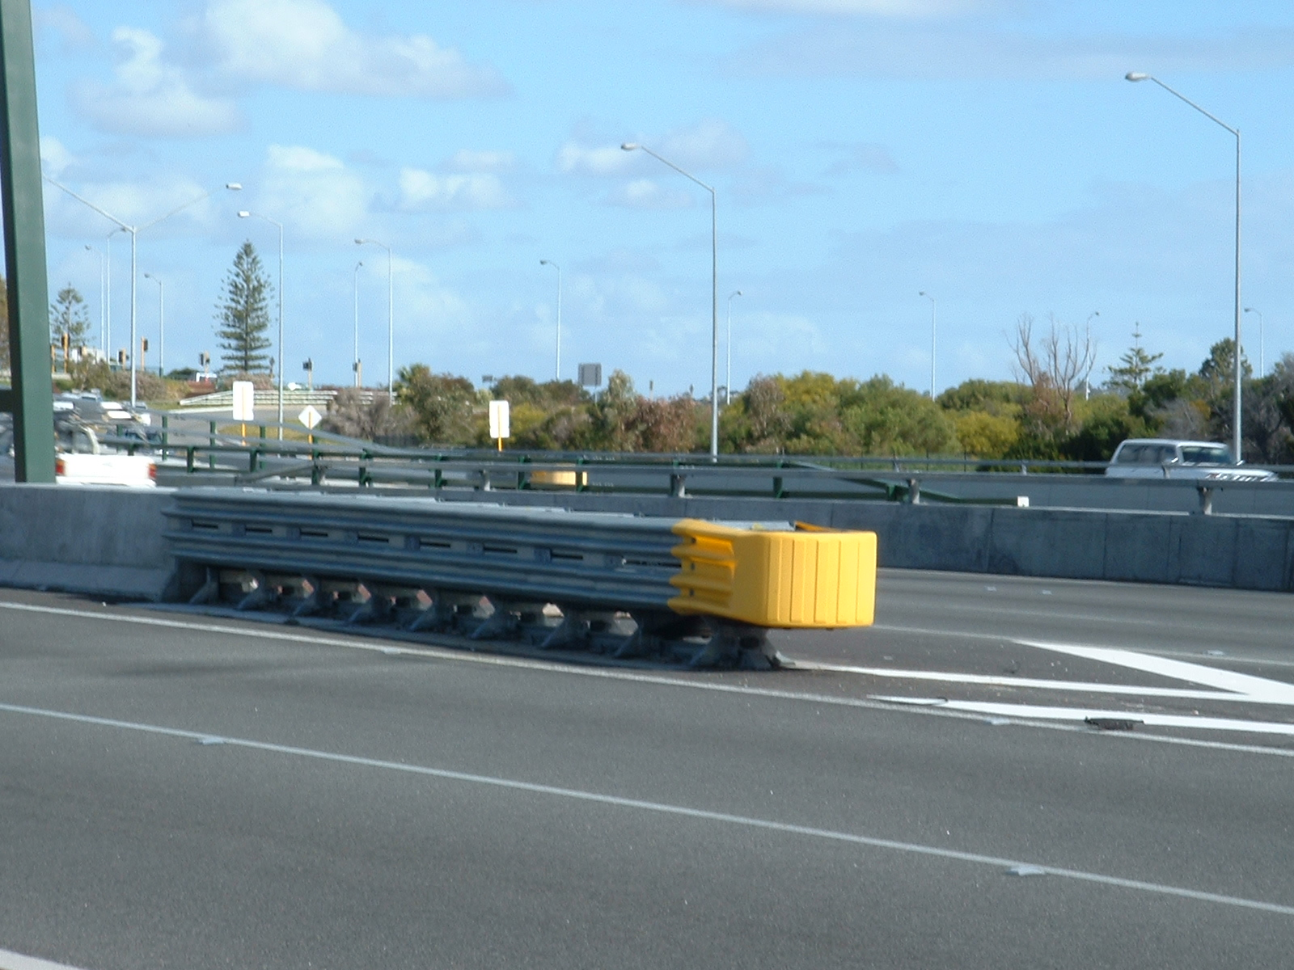

1. Steel barriers surrounding bridge pylons on the freeway have plastic ends bolted to them, as shown in the photograph. In terms of momentum and impulse, explain the presence of the plastic ends and how they act as a safety device. **[4 marks]**

2. A tennis ball of mass 60.0 g has a velocity of 15.0 ms-1 to the west when it makes contact with a tennis racquet. After contact, it leaves the racquet with a velocity of 35.0 ms-1 to the east. Determine the change in momentum of the tennis ball during the time it was struck by the racquet. **[4 marks]**

3. An area of land is an average of 2.00 m below sea level. To prevent flooding, pumps are used to lift rainwater up to sea level and pump it away. What is the minimum power output of the pump required to deal with 1.30 x 109 kg of rain per day? **[4 marks]**

4. (a) Measure the length and width of the shape drawn, giving the associated absolute uncertainty. **[3 marks]**

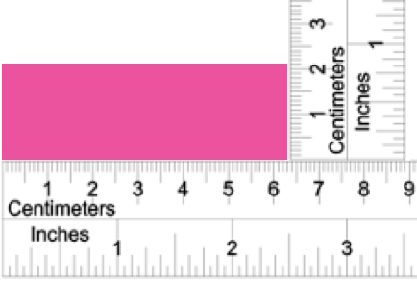

length: ±

width: ±

(b) Calculate the area of the rectangle (in m2), giving the final answer with the associated relative (percentage) uncertainty. **[4 marks]**

5. A helicopter of mass 3.10 tonnes is kept at a constant height and propelled forwards by a single lift force from its rotors of 3.25 x 104 N acting at an angle of 20.8 ° to the vertical.

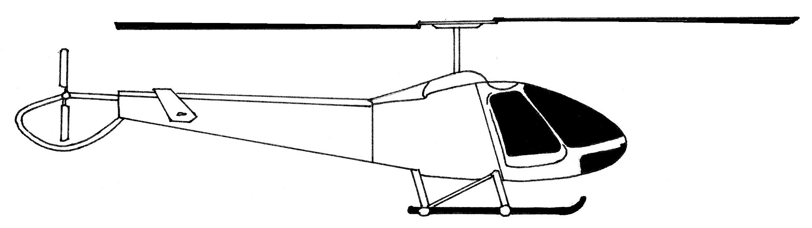

20.8°

Force from rotors acts at an angle of 20.8° to the vertical

(a) Calculate the horizontal force supplied by the lift force. **[2 marks]**

(b) Determine the work done by the force from the rotors to move the helicopter horizontally forwards by a distance of 65.0 m. **[2 marks]**

6. Tim performed a "bombie' off the five-metre board at the local pool after bouncing on its end. Given his time of flight is 1.45 s and his centre of gravity moves 6.00 m downwards from his launch position, calculate his initial vertical velocity as he leaves the board. (Ignore any sideways movement.) **[4 marks]**

7. The diagram below shows the changes which occur between the solid, liquid and gaseous phases of a substance, with the addition of heat.

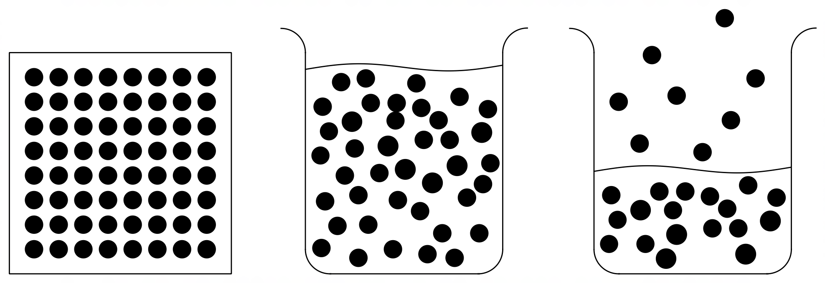

Using this diagram and your knowledge of the kinetic particle model, state and explain ***one change*** that occurs when the substance changes phase from:

(a) solid to liquid. **[2 marks]**

(b) liquid to gas. **[2 marks]**

8. In cold climates, wind chill factor and hypothermia can pose a real threat to the health of an individual. Wind chill is when cooler, moving air replaces relatively still air near the skin, giving the person the sensation that the effective temperature has decreased. Explain why the wind chill is worsened when the person is wet or wearing wet clothes. **[3 marks]**

9. A 6.50 kg steel container (specific heat capacity 4.50 × 102 Jkg-1K-1) holds 13.0 kg of water at 24.0 °C. When 3.15 kg of a molten alloy, at its melting point of 315 °C, is poured into the water, the water reaches a final temperature of 29.1 °C. If the latent heat of fusion of the alloy is 2.30 × 104 Jkg-1, determine the specific heat capacity of the alloy. **[5 marks]**

10. After running a long-distance marathon, Tori adds a handful of ice blocks to her partly-empty water bottle that contains water at room temperature. She knows that an average ice block contains anywhere from 30 to 50 mL of water. Tori also wants to ensure that the ice does not melt too quickly and only selects ice blocks that are well below freezing point.

Using this information, ***estimate*** how many kilojoules (kJ) of heat energy was extracted from the tap water in her water bottle by the ice gaining heat. **[5 marks]**

11. The second-fastest installed elevator reaches speeds of 20.5 ms-1 in the Shanghai Tower. Not only does the Gensler-designed Shanghai Tower boast the fastest elevator but also the longest continuous run of 578.5 m.

(a) Calculate the average acceleration of the lift if it reaches its top speed in 50.0 m from starting at the basement. **[3 marks]**

(b) What is the apparent weight of a 65.0 kg person in the lift while it is accelerating upwards? **[3 marks]**

**THIS PAGE HAS BEEN DELIBERATELY LEFT BLANK.**

**SECTION TWO: Problem Solving**

**Marks allotted: 100 marks out of 166 marks total.**

Attempt ALL 6 questions in this section. The marks allocated to each question are given and the answers should be written in the spaces provided.

**12. [13 marks]**

A traffic investigator comes upon the scene of an accident on a road where the speed limit is

70 kmh-1, and observes a damaged car at rest. A skid mark leading to the car is 50.0 m long.

The investigator knows that the mass of this car is 1.25 tonnes and that the frictional braking force when skidding was approximately 1.25 x 104 N. From this evidence, she is able to estimate the speed of the car immediately before the driver applied the brakes.

(a) Calculate the work done by the brakes in stopping the car. **[3 marks]**

(b) Using your answer from part (a), calculate the initial velocity of the car when the brakes were applied. (If you didn't get an answer for part (a), use W = 6.00 x 105 J.) **[3 marks]**

(c) Was the car speeding? Justify your answer. **[2 marks]**

(d) Determine the deceleration of the car and how long it took to stop. **[5 marks]**

**13. [15 marks]**

A roller coaster at a festival is set up by a carriage being hauled to the top by an electric motor. The mass of the carriage and the people is 505 kg and the vertical height is 31.0 m. The carriage is then released and moves under gravity.

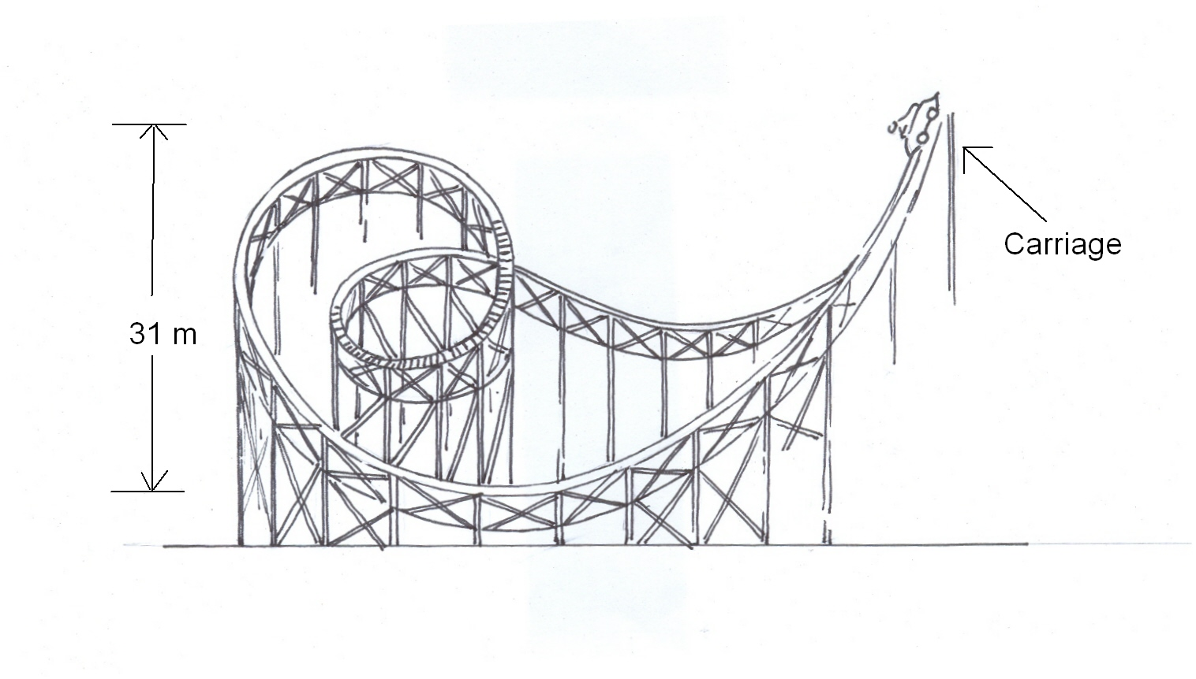

(a) Calculate the total energy of the carriage at the beginning of the ride. **[3 marks]**

(b) What is the theoretical speed of the carriage at the lowest point of the ride? **[3 marks]**

(c) The carriage is released and goes down the slope that is 70.0 m long, where the average frictional force is 30.0 N. What is the actual speed of the car when it reaches the lowest point? **[4 marks]**

(d) The diagram shows a loop of the ride lower in height to the beginning of the ride. Explain why this must be the case and not have the loop higher. **[2 marks]**

(e) What theoretical maximum vertical height could the carriage reach after moving through the bottom of the loop with the speed calculated in part (c)? **[3 marks]**

**14. [13 marks]**

A 45.5 g block of ice is heated from a temperature of -30.4 °C until it melts completely at 0.0 °C. Heat continues to be applied until the resulting liquid begins to boil at 1.00 x 102 °C.

(a) Calculate the amount of energy required to heat the block of ice from -30.4 °C until it begins to melt. **[2 marks]**

(b) Calculate the amount of energy required to melt the ice. **[2 marks]**

(c) Calculate the amount of energy required to heat the liquid from 0.0 °C to 1.00 x 102 °C.

**[2 marks]**

(d) Once the liquid had reached its boiling point, calculate the amount of energy required to boil it all off. **[2 marks]**

(e) A Bunsen burner supplied all of the heat in this example. Briefly describe how you could estimate the power output of the Bunsen burner, indicating any additional measurements that may be required to make this estimation. **[2 marks]**

(f) If it was determined that the Bunsen burner had a power output of 1.24 kW, calculate the amount of time taken for the solid ice (which was initially at -30.4 °C) to be completely boiled off using this Bunsen burner. **[3 marks]**

**15. [14 marks]**

Many homes use solar energy to heat water. One design uses solar collectors to directly heat water by the sun. The heated water is then stored for later use. There are two main components to these types of solar hot water systems:

• A solar collector, through which water passes and absorbs thermal energy from the sun. The water typically runs through copper tubes, which transfer the sun’s energy.

• A storage tank that stores hot water from the solar collector.

(a) In one design, the storage tank is located above the solar collector. Water circulates from the collector to the storage tank without the use of a pump. Explain how this happens. **[3 marks]**



(b) Calculate the internal energy of the water in the system if, over a period of an hour, the sun adds an amount of energy equal to 3.65 MJ to the water, but the system loses 1.40 MJ of its energy to the surroundings. **[2 marks]**

(c) Calculate the efficiency of the energy storage system from part (b). **[2 marks]**

(d) If the hot water system holds 3.00 x 102 L of water, calculate the increase in temperature of the water in one hour if the system absorbs 3.45 kW of solar energy (assuming all efficiency losses have been considered). Ignore the presence of the stainless-steel tank. **[4 marks]**

(e) The electrical heating element in the storage tank is rated at 4.80 kW. If it costs 25.7c per kWhr (unit), how much would it cost for the water to be heated to the same temperature using an electrical heating element? **[3 marks]**

**16. [12 marks]**

A roller coaster at a theme park undergoes the following motion in the first part of its journey.



(a) How far has the roller coaster travelled in this first part of its journey? **[5 marks]**

(b) Draw an acceleration-time graph for the motion, giving clear and accurate scales.

**[7 marks]**



**17. [12 marks]**

****James Bond uses a Walther PPK semi-automatic hand gun in the series of films. It has a mass of 0.590 kg and fires a 4.00 g bullet with a muzzle velocity of 335ms-1. Bond is at a gun range for practice before an assignment.

(a) Calculate the recoil velocity of the gun if Bond fires a bullet horizontally at a target. **[4 marks]**

(b) Is mechanical energy conserved in this situation? Justify your answer with an associated calculation. **[4 marks]**

(c) If the gun's recoil is absorbed by Bond's hand and arm in 5.00 ms, calculate the force exerted by him onto the gun. **[4 marks]**

**18. [21 marks]**

The rate at which heat is conducted through a material depends on several quantities relating to the physical environment and the shape and size of the material, as shown in the diagram below.

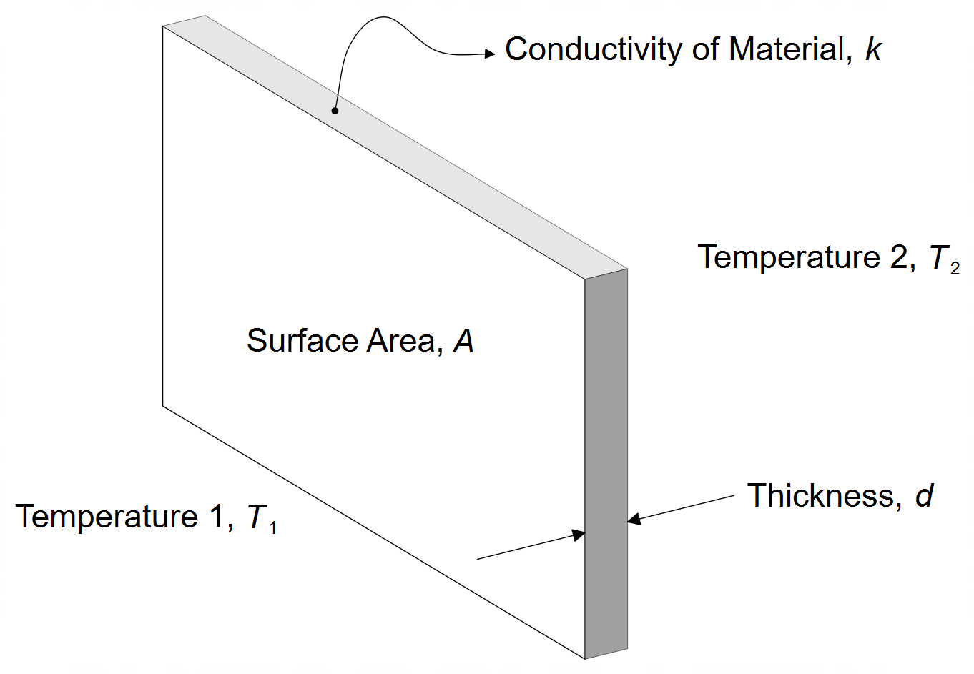

The rate at which heat is conducted through a material depends on the temperature ***T*** (K) on both sides of the material (T1 and T2), the surface area ***A*** (m2) exposed, the thickness of the material ***d*** (m) and the property of the material known as conductivity ***k***.

The rate of heat transfer through the material is power P (units of J s-1) and is given by:



(a) Correctly determine the units of conductivity ***k***. **[2 marks]**

(b) A single 1.20 m high by 2.30 m wide by 6.00 mm thick glass window separates a 28.0 °C exterior from the 18.0 °C interior office space. The window is letting heat in at a rate of

3.59 kW.

(i) Determine the conductivity ***k*** of the glass window. **[3 marks]**

(ii) Calculate the theoretical rise in temperature of the 215 kg of air within the office over a period of 15.0 minutes (the specific heat capacity of air is 1.10 ×103 Jkg-1K-1). **[4 marks]**

(c) The owner of the office decides to replace the window with a double-glazed window in order to reduce heat transfer. The double-glazed window has identical dimensions to the single pane window (1.20 m by 2.30 m) but is 30.0 mm thick and consists of two panes of glass separated by a sealed section containing air.

In order to test this double-glazed window, the amount of energy conducted per second through the window and the difference in temperature across the window is recorded for eight trials, as shown below.

|  |  |  |  |  |  |  |  |  |
| --- | --- | --- | --- | --- | --- | --- | --- | --- |
| **Trial** | **1** | **2** | **3** | **4** | **5** | **6** | **7** | **8** |
| **Temp Difference** (K) | 2.0 | 3.0 | 6.0 | 9.0 | 12.0 | 14.0 | 17.0 | 19.0 |
| **Energy Rate**  (Js-1) | 24 | 30 | 72 | 100 | 125 | 155 | 192 | 212 |

(i) Explain why the sealed section containing air reduces heat transfer. **[1 mark]**

(ii) Use the data in the table above to construct a graph by plotting Energy Rate on the vertical axis and Temp Difference on the horizontal axis. Include title, axes labels, units and a line of best fit. **[4 marks]**

  (iii) Calculate the gradient of the line of best fit. Indicate construction lines on the graph. **[4 marks]**

(iv) Use the value of the gradient of the line of best fit and information given in the question to determine a value for the conductivity ***k*** of the double-glazed window. **[3 marks]**



**SECTION C: Comprehension and Interpretation**

**Marks Allotted: 16 marks out of 166 marks total.**

Read the passage carefully and answer all of the questions at the end. Candidates are reminded of the need for correct English and clear and concise presentation of answers. Diagrams (sketches), equations and/or numerical results should be included where appropriate.

**[16 marks] ACTIVE SOLAR THERMAL SYSTEMS**

Active thermal systems are generally more complex than passive thermal systems. In addition to the solar collector and heat storage tank, active systems have a heat transfer control unit. This unit controls the flow of heat from the collector to the heat storage system.

The heat transfer control unit usually consists of one or more pumps or fans, which control the flow of water, air or other fluids through the entire system.

Active thermal systems are usually designed to operate at high constant temperatures. Pumps or fans control the flow of fluid so that the temperature of the fluid leaving the collector is maintained at a constant temperature. Common uses for active thermal systems are in air-conditioning, electricity generation and providing heat for industrial processes.

The solar collectors used in active thermal systems can be concentrating or non-concentrating collectors. A concentrating solar collector concentrates the solar radiation onto a small area by the use of mirrors or lenses. Non-concentrating collectors are often referred to as flat-plate collectors and are used in many industrial processes requiring hot water, such as washing bottles, where it is necessary to maintain the water at a certain temperature.

The simplest way to do this is by controlling the flow of water between the collector and the heat storage tank. In an active thermal system, the flow of liquid is controlled by pumps. Whenever the temperature in the collector is greater than that at the bottom of the storage tank, the pumps are started. The pumps are stopped when the temperature in the collector is no longer higher than the storage tank temperature.

Two examples of non-concentrating active solar thermal systems are the solar pond and the solar air-conditioner.

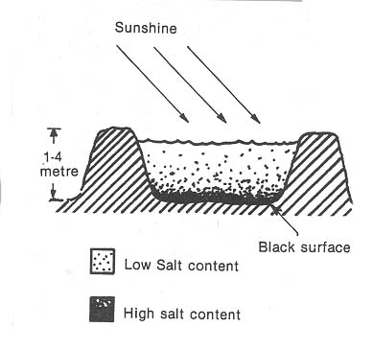

Figure 1

***Solar Pond***

A solar pond can be used to generate electricity and provide low-temperature heat for industry. The pond is a body of water between one and four metres in depth (see Figure 1). The surface area of the pond also affects the amount of solar radiation it can collect. A dark surface at the bottom of the pond increases the absorption of solar radiation.

The pond is filled in stages with water containing different amounts of salt. The bottom 'layer' contains the most salt and the top 'layer' is fresh water.

When solar radiation strikes the pond, most of it is absorbed by the pond. The temperature of the dense salt water layer near the bottom surface is higher than the fresh water layer near the surface of the pond. Heat stored by the salt water is piped to an evaporator. Liquid freon in the evaporator is heated and changes into a gas (see Figure 2). The pressure generated by the gas spins a turbine and electricity is produced from the generator. Freon gas is then cooled and recycled to be used again.

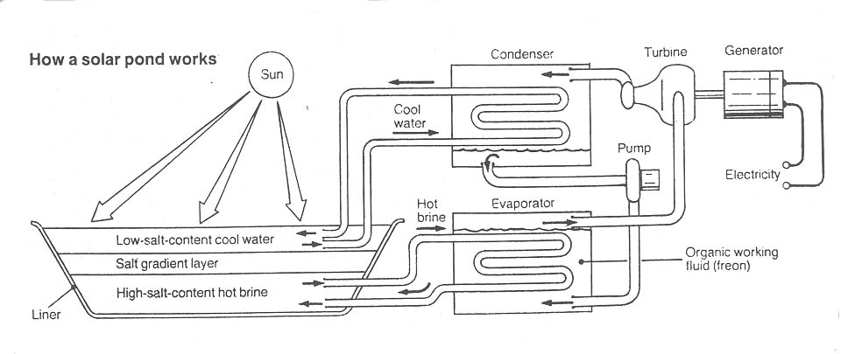

Figure 2

***Solar Air Conditioning***

Solar air conditioners consist of a solar collector, heat exchangers, a cooling system and an absorbent and refrigerant to transfer heat through the system (see Figure 3). In the solar air conditioner, the refrigerant is water and the absorbent is a salt, such as lithium bromide. Heat absorbed by the solar collector is transferred to the absorbent/refrigerant mixture. The heat separates the water from the lithium bromide.

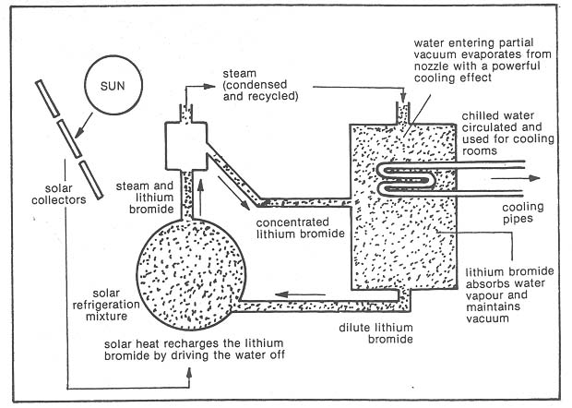

Figure 3

Water vapour is condensed and then evaporated at low pressure. This evaporation produces the cooling effect. The vapour then combines with the lithium bromide and heat is released in this process. The cycle can continue and be repeated. During this process, heat is absorbed from water running through the cooling pipes. This chilled water can then be used for cooling purposes.

1. Apart from their complexity, what is the essential difference between an active thermal system and a passive thermal system? **[2 marks]**

2. Why would you expect the temperature of the liquid at the top of the storage tank to be higher than at the bottom? **[2 marks]**

3. How would the surface area of a solar pond affect the amount of solar radiation it can collect? **[2 marks]**

4. Why is the bottom of the solar pond painted black? **[2 marks]**

5. Why would the solar pond be less effective if the depth of the pond exceeded about

4 metres? **[2 marks]**

6. What is the purpose of having layers of water of different densities in the solar pond? **[2 marks]**

7. What is the major limiting factor in locating solar ponds for production of electricity? **[2 marks]**

8. Refer to Fig. 2 to answer this question. How does the water entering the partial

vacuum produce a powerful cooling effect? **[2 marks]**

**END OF EXAMINATIONADDITIONAL WORKING SPACE**

**ADDITIONAL WORKING SPACE**

